7COM1079-0901-2025 - Team Research and Development Project

Final report title: A Comparison of Mean CO₂ Emission Levels Across Countries Between 1990 and 2021

Group ID: A 176

Dataset number: ds090

Prepared by: Saliny Vijayarasa (24147540)
Jathurshan Sabaraththinam (24151335)
Mathushanth Srikandarajah (24146280)
Tharankitha Baskaran (24160755)

University of Hertfordshire
Hatfield, 2025

Table of Contents

1. Introduction 4
1.1. Problem statement and research motivation 4
1.2. The data set 4
1.3. Research question 4
1.4. Null hypothesis and alternative hypothesis (H0/H1) 4
2. Background research 5
2.1. Research papers 5
2.2. Why RQ is of interest (research gap and future directions according to the literature 5
3. Visualisation 5
3.1. Appropriate graphs for the RQ 5
3.2. Additional information relating to understanding the data 7
3.3. Useful information for the data understanding 7
4. Analysis 8
4.1. Statistical test used to test the hypotheses and output 8
4.2. The null hypothesis is rejected /not rejected based on the p-value 8
5. Evaluation – group’s experience at 7COM1079 8
5.1. What went well 8
5.2. Points for improvement 8
5.3. Group’s time management 9
5.4. Project’s overall judgement 9
5.5. Comment on the GitHub log output 9
6. Conclusions 9
6.1. Results explained 9
6.2. Interpretation of the results 9
6.3. Reasons and/or implications for future work, limitations of your study 10
7. Reference list 10
8. Appendices 11
A. R code used for analysis and visualisation 11
B. GitHub log output. 12

Table of Figures

Figure 1: Box plot from R script - CO2 Emissions in 1990 and 2021 6
Figure 2: Histogram from R Script - CO2 Emission Differences (2021 - 1990) 6
Figure 3: C02 Emission Between 1990-2021 Normal Curve Histogram 7

1. Introduction

Problem statement and research motivation
Human activity releases CO₂, which is a primary cause of climate change. The year 1990 is a crucial benchmark in climate policy for measuring progress. While global agreements and technology have existed for decades, worldwide emissions continue to rise, though patterns differ by country. It is therefore important to examine national CO₂ data over time to assess if mitigation efforts are working. Earlier research, like the study by Raupach et al. (2007), confirms an upward trend since the late 1900s. However, few studies statistically test whether the change between two key years for specific countries is significant, which is the focus of our research.

The data set
For our analysis, we use the dataset called ds090, which lists the yearly CO₂ emissions for many countries over several decades. We focus on two key years: 1990 and 2021. Each entry is a country's total emissions for that year, measured on a ratio scale (so zero means none, and 10 million tons is truly twice 5 million). After cleaning, we have one value for each year per country, allowing a direct comparison of mean emissions between these two points in time.

Research question
Is there a difference in the mean CO₂ emission rate between 1990 and 2021 across countries?
In other words, when we look at all the countries together, has there been a real statistical change in their average emissions? We are looking at every country that has data for both years.

Null hypothesis and alternative hypothesis (H0/H1)
Because each country gives us one data point for 1990 and one for 2021, the two sets of numbers are linked together as matched pairs. This leads to our two hypotheses:

H₀ (Null hypothesis): The mean CO₂ emission rate across countries in 1990 is equal to the mean CO₂ emission rate in 2021.

H₁ (Alternative hypothesis): The mean CO₂ emission rate across countries in 1990 differs from the mean rate in 2021.

To test this, we should use a paired t-test if the differences between the years look approximately normal. If the data aren't normal, we will use the Wilcoxon signed-rank test instead.

Background research

Research papers
Several research papers have examined long-term trends in global CO₂ emissions, which supports the relevance of our dataset. (Raupach et al., 2007) analysed global and regional CO₂ emission drivers and found a clear increase in emissions after 1990 due to population growth, industrialisation, and higher energy demand. Their results show that many countries follow similar rising emission patterns, which is consistent with the structure of our dataset from 1990 onwards.
(Crippa et al., y2020) compiled a comprehensive open-access dataset of fossil fuel CO₂ and greenhouse gas emissions for all countries. Their work highlights that most nations have experienced substantial changes in emission levels over time, influenced by economic development and energy policies. This supports our use of country-level data to compare two distant years.
(Liu et al., 2020) used near-real-time monitoring to analyse how global emissions evolve year by year. They found that short-term events, such as the COVID-19 pandemic, temporarily reduced emissions, but long-term patterns remain dominated by structural economic factors.
Together, these studies demonstrate that CO₂ emissions vary significantly over time and across countries. This provides strong justification for testing whether the mean CO₂ emission rate differs between 1990 and 2021 in our dataset.
  - Why RQ is of interest (research gap and future directions according to the literature)
Our research question is important because many studies show rising global emissions over recent decades, but few statistically test whether the change between specific benchmark years is significant. The year 1990 is widely used in climate policy as a baseline, while 2021 represents the most recent year with complete data in our dataset. Comparing these two years helps us understand whether global efforts, technological improvements, or economic changes have made a measurable impact. By using statistical testing rather than simple visual comparison, our study contributes evidence on whether long-term CO₂ emission trends show a meaningful difference across countries.

Visualisation

Appropriate graphs for the RQ
The box plot compares CO₂ emissions in 1990 and 2021 across countries, providing a clear visual evaluation of changes in the central tendency and variability. The histogram showing the emission differences, including the normal curve, displays the distribution over time. These visualizations directly support the evaluation of median differences between the two years.
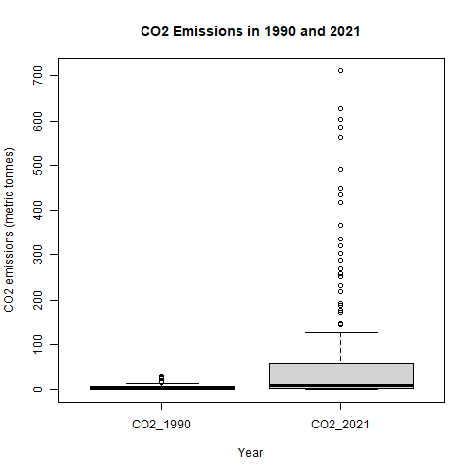
Figure 1: Box plot from R script - CO2 Emissions in 1990 and 2021
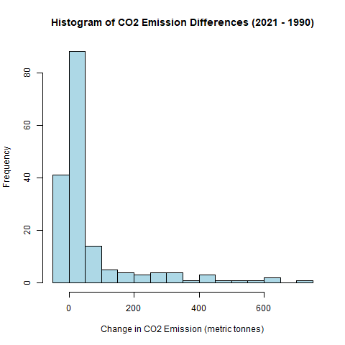
Figure 2: Histogram from R Script - CO2 Emission Differences (2021 - 1990)
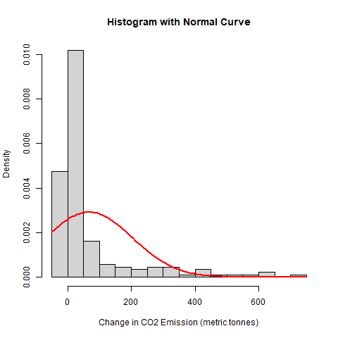
Figure 3: C02 Emission Between 1990-2021 Normal Curve Histogram
  - Additional information relating to understanding the data
The box plot highlights the distribution, median values, and outliers for each year, helping identify shifts in central tendency and spread. The histogram and normal curve indicate whether changes follow a normal distribution or exhibit skewness, informing the suitability of parametric tests such as the paired t-test.

Useful information for the data understanding
The box plot suggests higher emissions in 2021 with greater variability, indicating increased drift among countries. The histogram shows a right-skewed distribution of differences, with many countries increasing emissions and fewer showing declines. Together, the plots and the Wilcoxon test (p < 0.001) indicate that global CO₂ output rose overall between 1990 and 2021.

Analysis

Statistical test used to test the hypotheses and output
The statistical test was chosen based on a Shapiro-Wilk test, which showed the paired differences were non-normal (W = 0.57993, p < 2.2×10⁻¹⁶). This violation of normality meant the non-parametric Wilcoxon signed-rank test was the appropriate choice for the paired data. The test result (V = 13224, p < 2.2×10⁻¹⁶) directly addresses the research question, showing a statistically significant difference in mean CO₂ emissions between 1990 and 2021.

The null hypothesis is rejected /not rejected based on the p-value
The Wilcoxon signed-rank test was used because the differences between 1990 and 2021 were clearly not normally distributed, as shown by the Shapiro–Wilk result (W = 0.5799, p < 2.2×10⁻¹⁶). The Wilcoxon test showed a very strong statistical difference between the two years (V = 13224, p < 2.2×10⁻¹⁶). Therefore, we reject the null hypothesis and conclude that CO₂ emissions in 2021 were significantly different from those in 1990. The boxplot and the positive shift in the data both indicate that emissions were generally higher in 2021, reflecting substantial increases for many countries despite international efforts to reduce them.

Evaluation – group’s experience at 7COM1079

What went well
Our group collaborated effectively from the beginning, dividing tasks based on individual strengths. Communication was consistent using GitHub, Teams, and group meetings, which made it easy to track progress and resolve issues quickly. Data preparation and analysis were completed smoothly, with members contributing high-quality work on time. The R-based visualisations and statistical testing aligned well with our research question, allowing us to produce coherent and well-structured results. Overall, teamwork and technical coordination worked very well.

Points for improvement
Although the project progressed smoothly, some tasks took longer than expected due to differing levels of statistical and coding experience. Earlier alignment on responsibilities could have reduced delays in visualisation and interpretation stages. We also identified that more frequent short check-ins might have helped maintain momentum, especially close to deadlines. Improving documentation on GitHub—such as clearer commit messages and more structured branches—would strengthen traceability and collaboration in future group projects.

Group’s time management
Overall time management was satisfactory, with early stages completed promptly. However, the analysis and write-up sections required more time than anticipated. We caught up by increasing coordination during the final week. A more structured schedule and intermediate milestones would help future projects run even more smoothly.

Project’s overall judgement
The project was successful and met its objectives. We investigated the research question thoroughly, supported by appropriate statistical methods and clear visualisations. Collaboration was effective, and the final output reflects a solid understanding of data analysis processes. The experience strengthened our skills in R, teamwork, and reproducible research practices.

Comment on the GitHub log output

- Commit: - "Statistical test"
Impact: - Improved our histogram to better show the emission distribution.

- Commit: - "update visualization code Histogram"
Impact: - Enhanced the graph's clarity and easy to analyse.

- Commit: - "Updated Background Research"
Impact: - This commit added stronger context explaining why our research question matters.

Conclusions

Results explained
The statistical analysis shows a clear and significant difference in CO₂ emissions between 1990 and 2021 across countries. The Wilcoxon signed-rank test, selected due to the non-normal distribution of the differences, produced a highly significant result (V = 13224, p < 2.2×10⁻¹⁶). This confirms that emission levels in 2021 were not the same as those in 1990. The boxplot also demonstrates a noticeable rise in the central tendency and spread of emissions over time.

Interpretation of the results
These findings suggest that global CO₂ emissions have increased substantially over the three decades, aligning with literature that highlights growth in energy consumption, industrial expansion, and economic development as major drivers. While some countries have implemented policies that slowed emission growth, these improvements appear to be outweighed by large increases in others, particularly emerging economies. This imbalance contributes to the statistically significant rise observed in the dataset, reinforcing concerns about limited effectiveness of mitigation efforts.

Reasons and/or implications for future work, limitations of your study
This analysis only compares two years and does not include factors like population, economic activity, or regional differences. Future work could look at changes over more years, use per-capita emissions, or examine links with GDP and renewable energy. This would help explain what influences emission changes more clearly.

Reference list
- Raupach, M.R., Marland, G., Ciais, P., Le Quéré, C., Canadell, J.G., Klepper, G. and Field, C.B. (2007) ‘Global and regional drivers of accelerating CO₂ emissions’, Proceedings of the National Academy of Sciences, 104(24), pp. 10288–10293. https://doi.org/10.1073/pnas.0700609104
- Crippa, M., Oreggioni, G., Guizzardi, D., Muntean, M., Schaaf, E., Lo Vullo, E., Solazzo, E., Monforti-Ferrario, F., Olivier, J.G.J. and Vignati, E. (2020) Fossil CO₂ and GHG emissions of all world countries – 2020 report. Publications Office of the European Union. https://doi.org/10.2760/143674
- Liu, Z., Ciais, P., Deng, Z., Lei, R., Davis, S.J., Feng, S. et al. (2020) ‘Near-real-time monitoring of global CO₂ emissions reveals the effects of the COVID-19 pandemic’, Nature Communications, 11(1), p. 5172. https://doi.org/10.1038/s41467-020-18922-7

Appendices

R code used for analysis and visualisation
#install.packages("tidyverse")
library(tidyverse)

# Load dataset and keep original names
CO2 <- read.csv("tidy_format_co2_emission_dataset.csv", check.names = FALSE)

# Rename to simple names
colnames(CO2) <- c("country", "year", "CO2")

# Convert CO2 to numeric
CO2$CO2 <- as.numeric(CO2$CO2)

#remove rows with null CO2
CO2 <- CO2 %>% drop_na(CO2)

# Filter two years
CO2_1990 <- CO2 %>%
filter(year == 1990) %>%
select(country, CO2_1990 = CO2)

CO2_2021 <- CO2 %>%
filter(year == 2021) %>%
select(country, CO2_2021 = CO2)

# Merge & compute differences
paired <- inner_join(CO2_1990, CO2_2021, by = "country") %>%
mutate(diff = CO2_2021 - CO2_1990)

# BOXPLOT
png("boxplot_CO2_1990_2021.png")
paired_long <- paired %>%
pivot_longer(cols = c(CO2_1990, CO2_2021),
names_to = "year",
values_to = "co2")

paired_long$year <- recode(paired_long$year,
"co2_1990" = "1990",
"co2_2021" = "2021")

boxplot(co2 ~ year, data = paired_long,
xlab="Year",
ylab="CO₂ emissions (metric tonnes)",
main="CO₂ Emissions in 1990 and 2021")
dev.off()

# HISTOGRAM
png("hist_diff_CO2.png")
hist(paired$diff, breaks=20,
main="Histogram of CO2 Emission Differences (2021 - 1990)",
xlab="Change in CO2 Emission (metric tonnes)",
ylab="Frequency",
col = "lightblue")
dev.off()

# Add normal curve
png("hist_diff_normal_curve.png")
hist(paired$diff, freq = FALSE, breaks = 20,
main = "Histogram with Normal Curve",
xlab = "Change in CO2 Emission (metric tonnes)")
curve(dnorm(x, mean = mean(paired$diff), sd = sd(paired$diff)),
col = "red", lwd = 2, add = TRUE)
dev.off()

# STATISTICAL TESTS
shapiro.test(paired$diff)
t.test(paired$CO2_2021, paired$CO2_1990, paired = TRUE)
wilcox.test(paired$CO2_2021, paired$CO2_1990, paired = TRUE)

GitHub log output.
